1:- Node version 8.9.3

2:- Python version 2.7.14

3:- Java 64 bit

4:- Global install react native  
npm install -g react-native-cli

5:- environment variable settings  
  
Android home

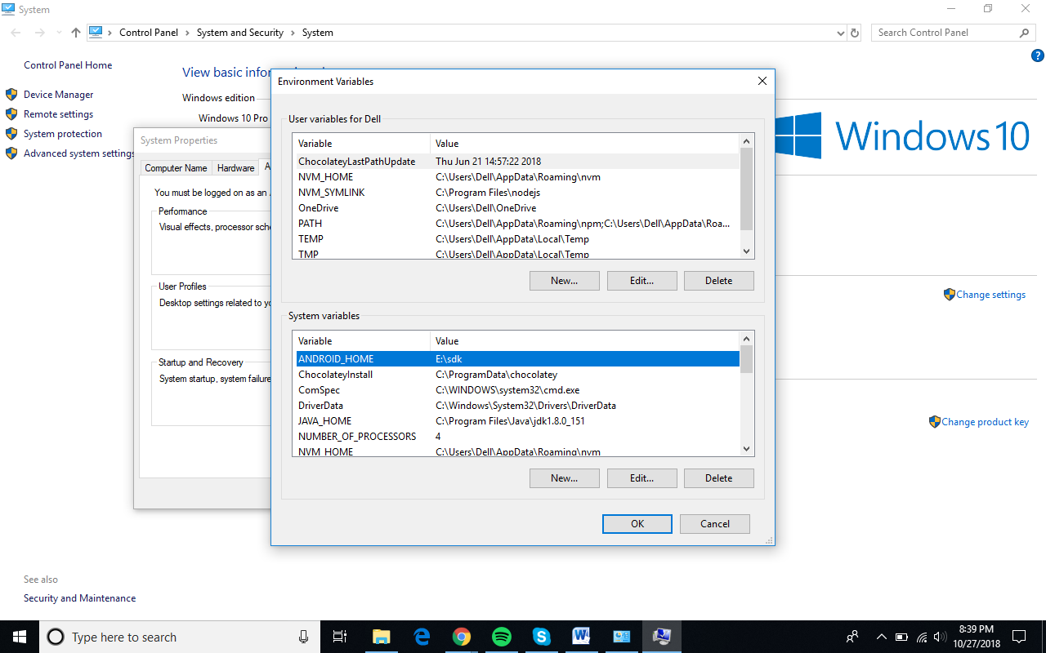

Java Home

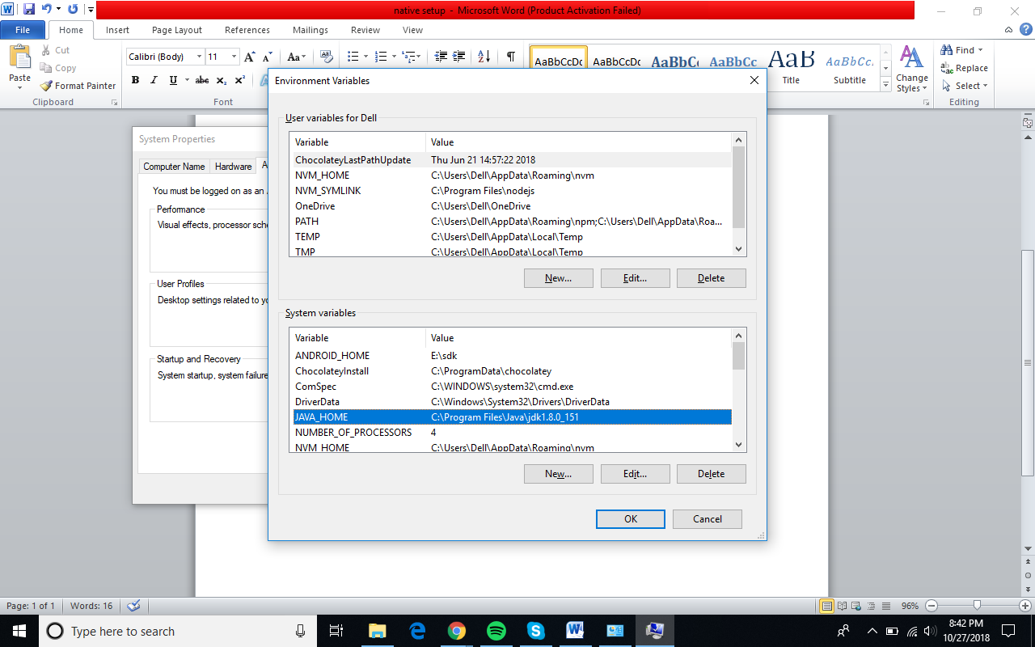

Platform Tools  
  
